**Internship Appointment Letter**

Dear Mamun Or Rashid,

You will be happy to know that you are selected for our non-paid remote internship program. We have been impressed with your background and would like to formally offer you the position of **Front-End Engineer (Intern) .**

This is remote internship with **working hour (9 AM to 5 PM)** . You will be reporting to the Senior Engineer. Your expected starting date is **01** **January, 2023.**

In the meantime, please feel free via email or phone, if you have any questions. We are all looking forward to having you on our team.

Wish you all the best for a better journey with us.

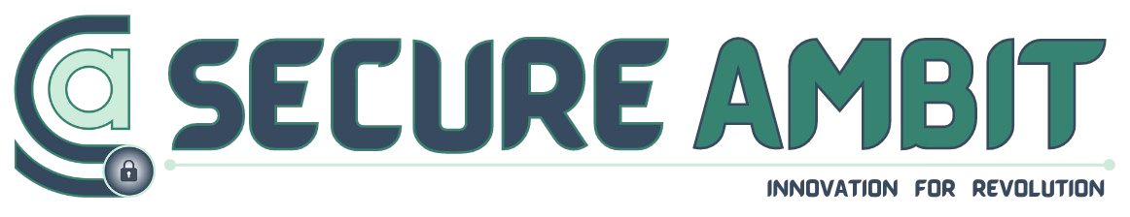

**Date: January 2, 2023**

Thanks From, Thanks From, HR, Secure Ambit. CEO, Secure Ambit.

*** This is an official document of Secure Ambit to confirm appointment.

**Mobile**: +8801875263163. **Email**: info@secureambit.com. **Website**: [www.secureambit.com](http://www.secureambit.com/) **Address:** Secure Ambit Head Office, Jamalpur Sadar, Mymensingh, Bangladesh.